DirectShow Filter Wizard

Introduction
The DirectShow Filter Wizard creates a blank filter for Transform and In-Place Transform Filters. It should save you considerable time in creating new filters.

Requirements
DirectX SDK 9.0
Visual Studio.Net

Installation
The below instructions assume the default installation location for Visual Studio.Net.
- Copy the files VCProjects\*.* to C:\Program Files\Microsoft Visual Studio .NET\Vc7\vcprojects.
- Copy the directory VCWizards\DSWizard to C:\Program Files\Microsoft Visual Studio .NET\Vc7\VCWizards.

Usage
To use the DirectShow Filter Wizards, run Visual Studio and select File|New|Project…, which will display the below window:

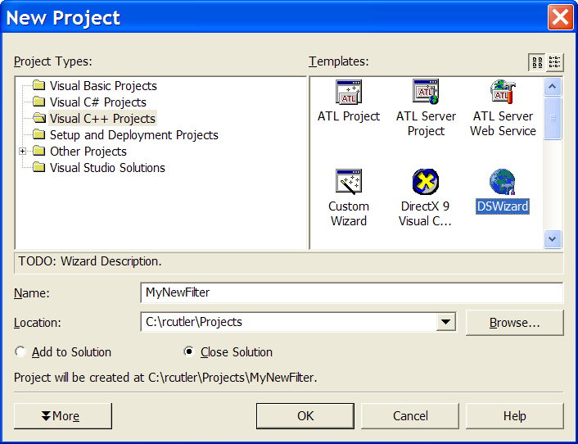

Select DSWizard, type in a filter name, and select OK. The next window allows you to select the transform type:

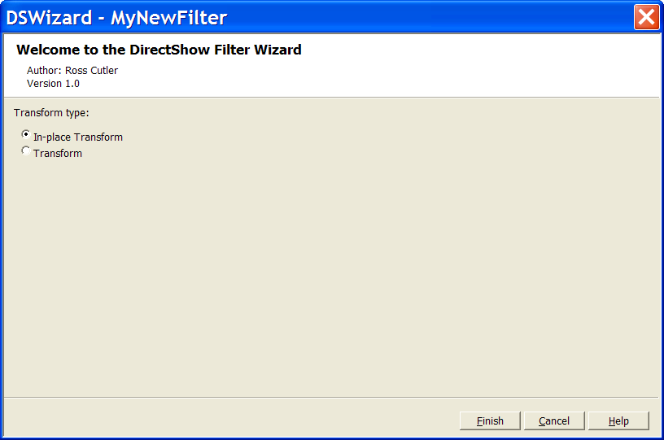

When you press Finish, you should be able to build the transform. Search for TODO comments to insert code.

Notes
- The created filter project assumes DirectX is installed in c:\dxsdk.
- You need to build the release and debug versions C:\DXSDK\Samples\C++\DirectShow\BaseClasses.

Todo
- Support Capture and Renderer Filters
- Support DMOs
- Support audio filter types

History
- 2/6/03 Ported VC6 wizards to VS.Net

Author
Ross Cutler

